3.ReactJS-HOL

Create a react app for Student Management Portal named scorecalculatorapp and create a function component named “CalculateScore” which will accept Name, School, Total and goal in order to calculate the average score of a student and display the same.

1. Create a React project named “scorecalculatorapp” type the following command in

terminal of Visual studio:



1. Create a new folder under Src folder with the name “Components”. Add a new file named “CalculateScore.js”

import '../Stylesheets/mystyle.css'

const percentToDecimal = (decimal) => { return (decimal.toFixed(2) + '%')

}

const calcScore = (total, goal) => { return percentToDecimal(total / goal)

}

export const CalculateScore = ({ Name, School, total, goal }) => (

<div className="formatstyle">

<h1><font color="Brown">Student Details:</font></h1>

<div className="Name">

<b><span> Name: </span></b>

<span>{Name}</span>

</div>

<div className="School">

<b><span> School: </span></b>

<span>{School}</span>

</div>

<div className="Total">

<b><span>Total:</span></b>

<span>{total}</span>

<span> Marks</span>

</div>

<div className="Score">

<b>Score:</b>

<span>

{calcScore( total, goal

)}

</span>

</div>

</div>

);

Code:

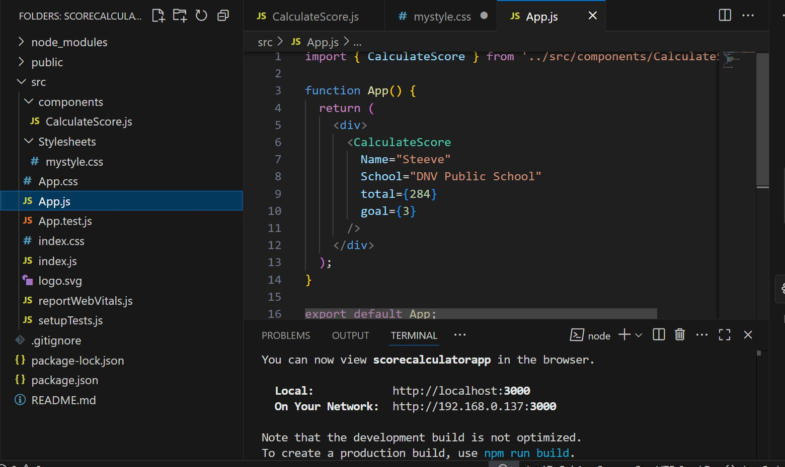

Output:

